Prince Adam
The Heir of Grayskull
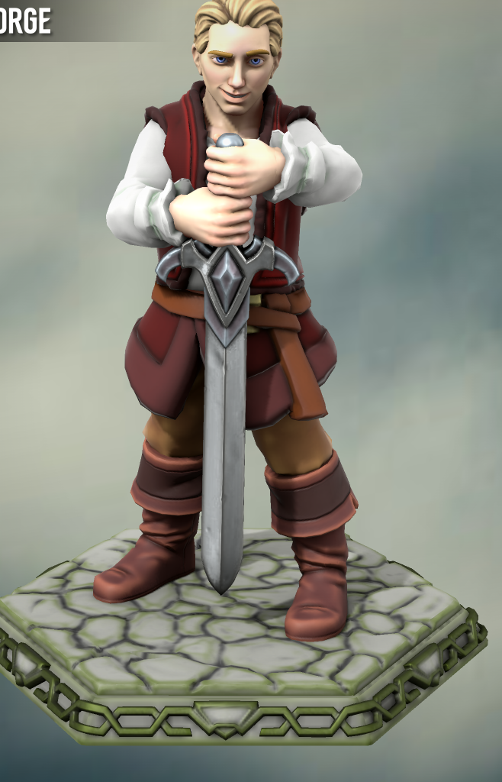
Age: 17 years
Sex: Male
Weight: 33 pounds
Species: Eternian-Human Hybrid

PERSONALITY
Adam is often brash, impulsive, and always ready to cause trouble. Though his mother Marlena finds this very amusing, and heartwarming, Randor is often frustrated that he doesn’t show much enthusiasm or competence in his royal duties as the prince. This is mostly due to his youth and inexperience, but as he spends time as He-Man, he quickly develops said wisdom and maturity and saves the spoiled, lazy, arrogant prince aspects of his personality as an act.

HISTORY
Adam is the son of King Randor and Queen Marlena, as well as the crown prince of Eternos. However, he doesn’t take it very seriously. Whenever he’s required to do anything that requires responsibility whether to the duties as the prince, or even normal teenage activities, he usually blows them off. He’ll either be pulling pranks with Orko, or sleeping in the stables with his pet Cringer.
Although on the surface he still does this, everything changes when Skeletor begins his campaign to conquer Eternia after nearly twenty years of peace. This is the crucible where Adam is called by the Sorceress of Castle Grayskull and takes the first steps to fulfill his destiny.

ROLE IN THE MOTU SAGA
Adam is one of the main overall protagonists in the MOTU Saga. Like most other versions of the He-Man franchise, he’s the main protagonist in the Masters of the Universe Series. He serves as a minor character in the Powers of Grayskull Prequel Trilogy, has a cameo in Keldor: The Lord of Destruction as an infant, and as a supporting character in the Princess of Power spin-off series. In the two-part crossover finale, Eternity Undone, he’s one of the three main protagonists along with his sister Princess Adora/She-Ra, and his love interest, Teela. Finally, in the sequel series, He-Ro: Son of He-Man, an older and wiser King Adam once again serves as a supporting character.

